

A Project Report On

**Placement Management System**

By

Reshma Anant Revankar

Batch: 2021-6258

Center: Bangalore-S Prayas

Under the Guidance of

Anjana Sarode

Technical Trainer

EduBridge

(School of Coding)

**Introduction:-**

Placement Management System a student/company information system is a web based system. It maintains a large database of students wherein all the information of student including the personal records and the academic performance.

The Placement Management System is developed as an attempt to take a record of company and student by restricting such a large database to that of a particular class of student or company. The System provides the facility of viewing both the personal and academic information of the student and company it can also search for eligible students and company and also insertion and deletion of records by the administrator. Eligible students will receive an email including the details of the company and also they will receive a sms on their registered mobile number in which the date-time and location will be provided.

**Modules:-**

* + - Admin Module
    - User Module

I have developed this application in Java, Hibernate and MySQL. It’s a web-based projects so I have used HTML, CSS, JavaScript and Bootstrap also.

The main feature of this project is to manage student information in the college with regard to placement. It improves existing system.

Admin can add departments, create new batches, add/delete drives. Students can directly join in placement drive if interested. Admin can manage the training programs conducted in the college. Admin is also able to analyze the placement activities of each student.

Placement officers have to manage the student’s profile and their documents. It is a platform where students can view and assess their opportunities. The system will be having different types of accounts for different types of users such as Admin, Student.

**Software Requirements:-**

**Front end:** Java/J2EE technologies , HTML, CSS, JavaScript, Bootstrap, Hibernate.

**Back end:** MySQL workbench 8.0.23CE.

**Middleware/Server:** Apache Tomcat v8.5.

**IDE:** Spring Tool Suite4.0

**Browser:** Best result on Google Chrome

**Operating System:** Window 8 & 10.

**Data Dictionary:-**

* create database Placement1;
* Hibernate: create table login(id bigint primary key auto_increment,username varchar(255),password varchar(255));
* Hibernate: create table College(id bigint primary key auto_increment,collegename varchar(255),collegelocation varchar(255),collegeadmin varchar(255),collegeemail varchar(255));
* Hibernate: create table Placement(id bigint primary key auto_increment,name varchar(255),college varchar(255),date varchar(255),qualification varchar(255),year varchar(255));
* Hibernate: create table Student(id bigint primary key auto_increment,studentname varchar(255),course varchar(255),percentage numeric,mailid varchar(255),college varchar(255),roll bigint,qualificaton varchar(255),hallticketno numeric);
* Hibernate: create table student_login(id bigint primary key auto_increment,username varchar(255),password varchar(255));

**Screenshots**

**Login Index:**

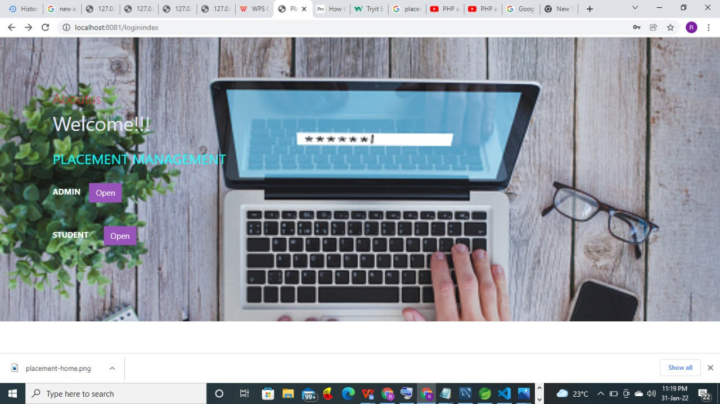

**Admin Login:**

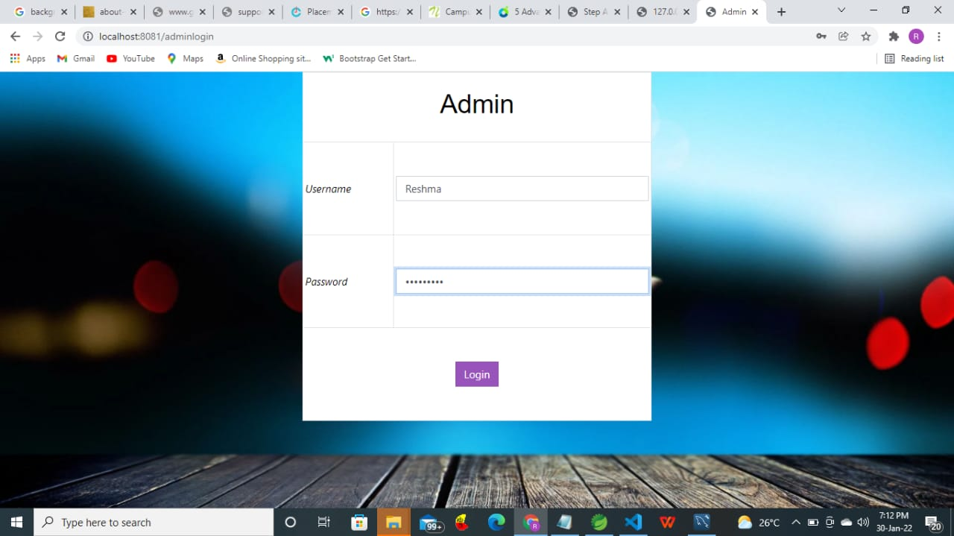

**Admin Index:**



**Placement Index:**

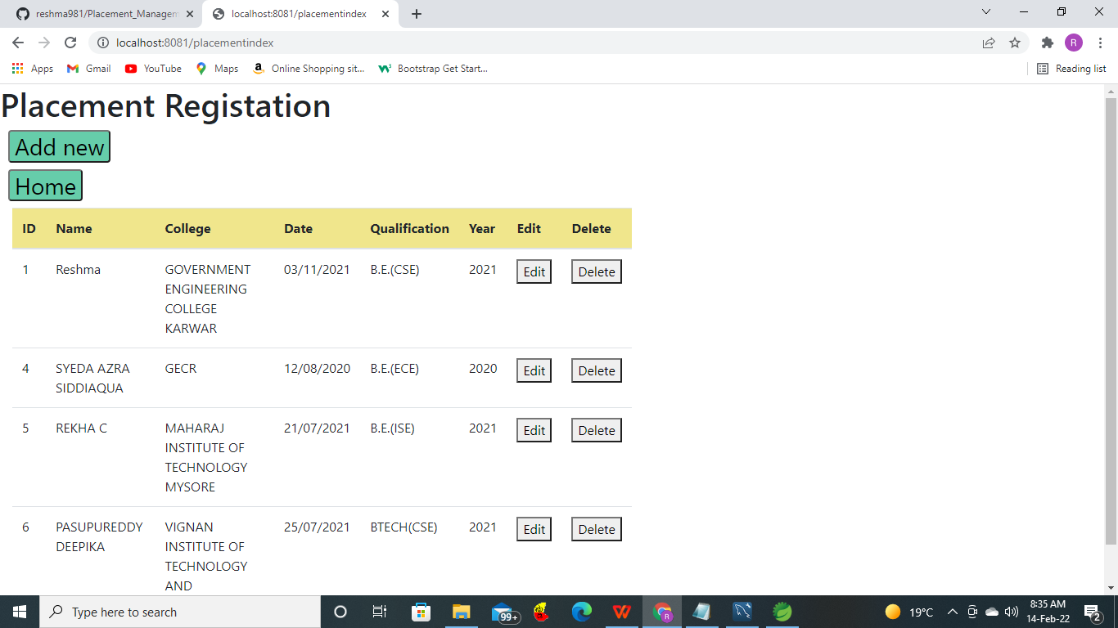

**College Index:**

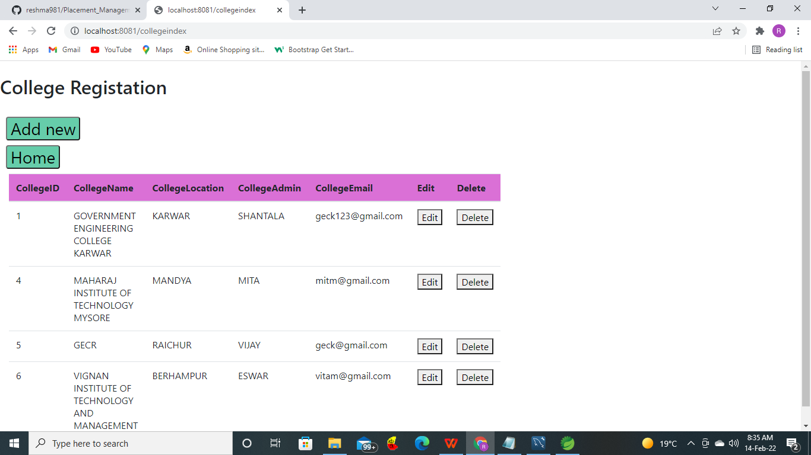

**Student Index:**

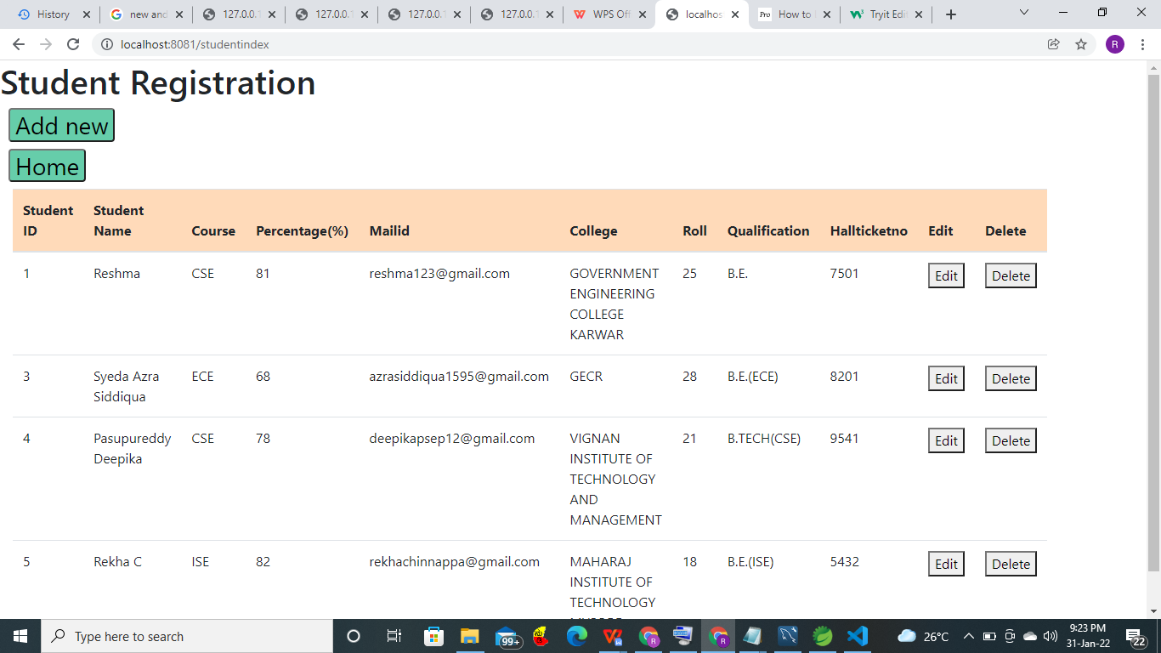

**Student Login:**

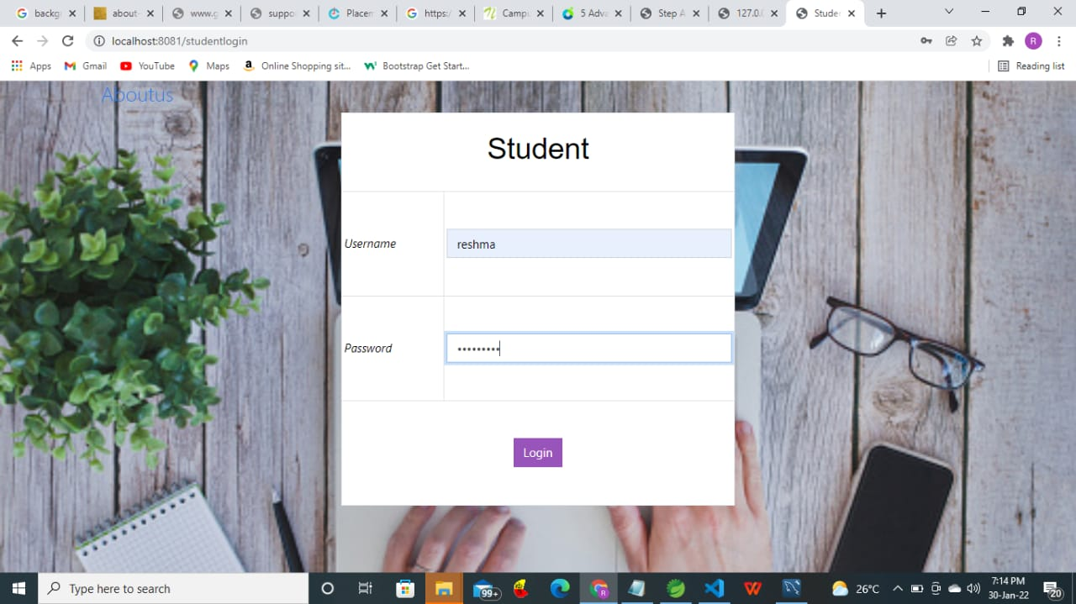

**Student Tab:**



**Aboutus:**



**Thank You**